**Newton Rhapson**

Xex is called exact vol which would equate BS price to market price. Xn is the estimated vol using Newton Rhapson Algo. Epsilon is the error term. Epsilon needs to be defined beforehand so that the algo stops when the error term is within this threshold.

We begin by doing Taylor series expansion of a function of Xex.

g(Xex) = g(Xn + e).

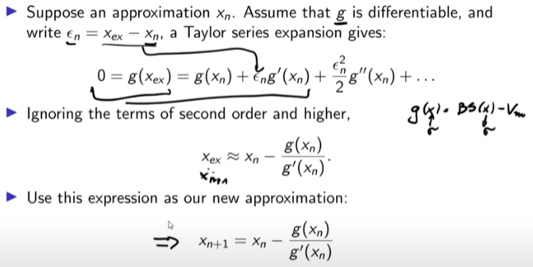

Since, g(X) = BS(X) - Market Price

Therefore, g(Xex) = BS(Xex) – Market Price = 0

The algo guessed Xn then using Xn it computes Xn+1. This Xn+1 is used as input in g().

g(Xn+1) = BS(Xn+1) – Market Price. If the difference or g(Xn+1) is greater than epsilon then another iteration is run. The algo keeps on iterating till it finds an Xn+1 which makes the error b/w BS price and market price less than the defined threshold.

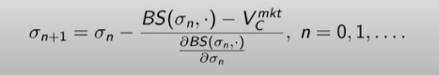

Just replaced X with sigma in the iterative process.

Another simple approach to arrive at the iterative process:  
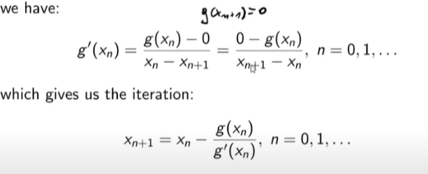

Again g(X) = BS(X) – Market price. Because we want to estimate a Xn+1 which equals Xex. Therefore, g(Xn+1) = 0 as Xn+1 vol would equate BS price to market price. Hence, we arrive at the same process again.